LUTHERAN CHURCH IN MALAYSIA · LCM FINANCE & HR
For an EXCO Member

Getting in
finance-pv.vercel.app
Open it in any browser, on a phone or a computer. Bookmark it the first time and you will not have to type it again.
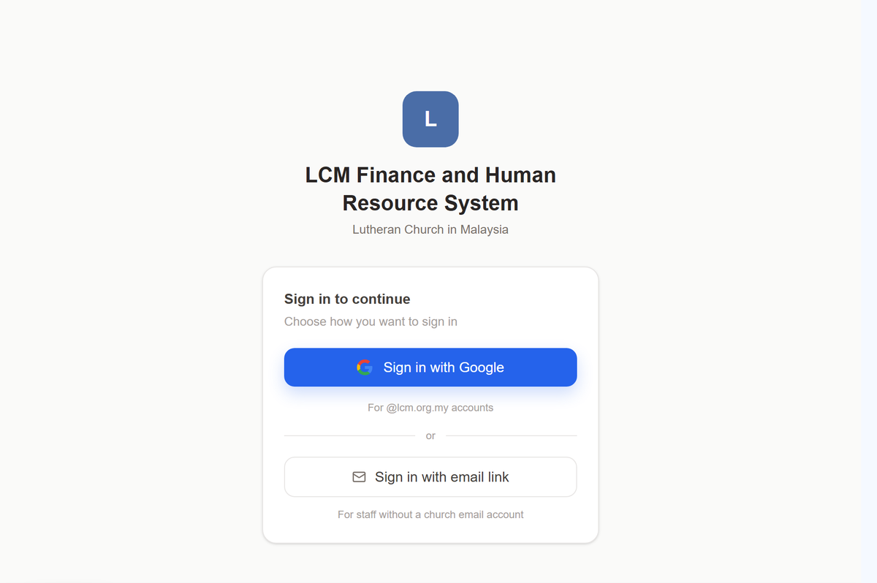
This is what you will see.
- Press Sign in with Google.
One tap, the same as opening your church email. Nothing to type.
- Use your @lcm.org.my Google account.
That is the address the church knows you by, and the one your approvals are recorded against.
No @lcm.org.my address? Contact the LCM Finance Executive and they will grant access to the personal email address you prefer to sign in with. This is usually the case for volunteers, who serve the church without being employed by it. Once they have granted it, sign in with Google using that address.

If the app looks emptier than this guide describes
Your role has not been set yet. Signing in gets you through the door; what you may do once inside is recorded by the HQ office, usually the same day. Ask them to set it, then sign in again.

Finding your way
Everything is reached from the list down the left. On a phone it is behind the menu button at the top.
The few things you do most often sit at the top of that list, not nested inside anything, so they are one tap from wherever you are. Everything else is grouped: open a group and its pages appear underneath it.
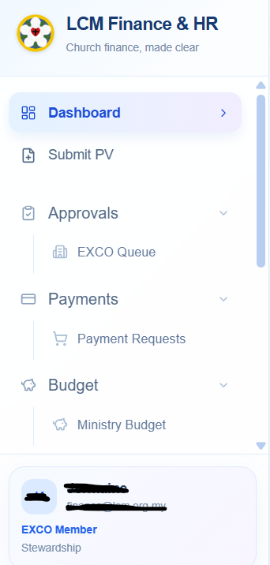
You will not see every group in this picture. The list is built from what your role may do, so what is missing is simply not yours.
Your name is at the foot of that list, with your role under it. If the role shown there is wrong, nothing else in the app will behave the way this guide describes — check it first, and ask the Finance Executive to correct it.

Verifying your ministry’s claims
Nothing is paid in your ministry’s name without your knowledge and approval. That is what verifying means, and it is the step the whole chain rests on.
Open Approvals → EXCO Queue. What is waiting on you is listed; anything already dealt with is not.
- Read the purpose and open the receipts. You are confirming two things: that this spending happened, and that it belongs to your ministry.
- Look at the budget line. The voucher says which line of your budget it comes out of and what is left of that line. If it says Unbudgeted, the spending is outside what was approved — that is not a refusal, but it is a question worth asking before you verify.
- Verify, or send it back with a reason. A reason is not optional when you send something back: it is for the submitter to ammend.
You are not checking the arithmetic. Finance does that afterwards, and the General Manager looks again after them. Your question is narrower and only you can answer it: is this ours, and did it happen?

Appointing a checker
You may also appoint a checker who essentially is a person that can assist you to collects the receipts and raises claims on your behalf (i.e. a coordinator on the ground). You can appoint them as your checker. They can help to confirm the particulars are right before the payment voucher reaches to you for verification
Please let the finance executive who may want to appoint as your checker and ask submit his or her email which will be used for login and access purposes. Please also note, that the person you choose must hold no portfolio of their own; the app will not let you appoint somebody who does, because a checker who could also verify would be checking their own work.

The budget
Open Budget. You see the ministries you are entitled to see — your own, or all of them.
Each ministry’s budget is a list of lines, one per project or activity. For each line: what was approved, what has been spent, what is committed but not yet paid, and what is left. The colour is a quick read — green has room, amber is close, red is over.
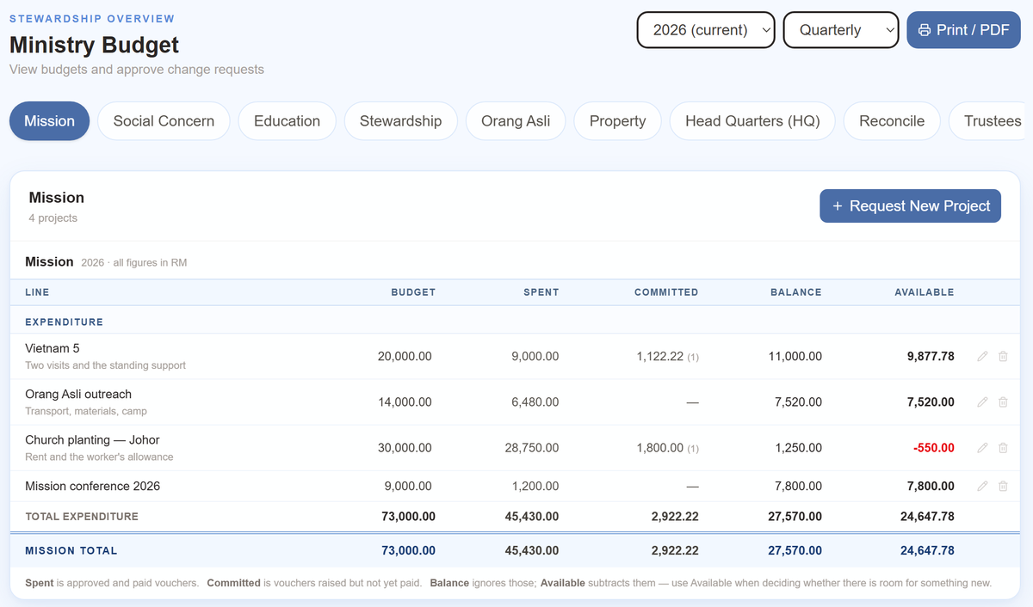
One row per project. Balance ignores what is committed; Available subtracts it, which is the figure to use when deciding whether there is room for something new. Church planting here has RM1,250 left on paper and is RM550 short once the voucher already in the chain is counted. The picture is an illustration only, figures are not actual
A payment voucher is tied to a budget line by its project name. That is why the ministry and project on a claim matter: a claim with no project is spending the budget cannot see, and it will show as Unbudgeted wherever it appears.

Proposing and amending a budget
Each year your ministry proposes what it expects to spend. During the year, if something changes, you ask for an amendment rather than quietly overspending.

Proposing
- Open Budget and choose your ministry and the year.
- Add a line for each project or activity, with what you expect it to cost and anything you expect it to bring in. Give each one a name you will recognise on a voucher a year from now — that name is how spending finds its way back to this line.
- Attach the papers behind any line that needs explaining.
- Submit it. It goes forward as a whole, to be decided by the EXCO at the meeting held for the budget. You will be told when it is approved or sent back.
The budget is settled in a meeting, not in the app. The EXCO votes on the year’s budget at a meeting called for that and nothing else, and you have a voice in it like every other member. What is entered afterwards records what was resolved — which is why your proposal needs to be in before the meeting, not after.

Amending one during the year
On the same page, ask for a change to a line — more, less, or a new line altogether — and say why. It goes forward the same way. The figures on the page do not move until the change has been agreed and recorded, which is deliberate: what you see is always what was actually decided.
An unbudgeted claim is not refused automatically. It is flagged to everybody who looks at it, including the officers who sign. If you know spending is coming that has no line, it is far easier to ask for the amendment first.

Claiming money back
Anyone can be owed money by the church — a volunteer who bought refreshments, a pastor who paid for petrol. Claiming is not something only staff may do, so Submit PV is in everybody’s list.
- Open Submit PV, at the top of the left-hand list.
- Select which Ministry it belongs to. It decides whose budget the money comes out of and who has to verify it, If you are unsure, ask that ministry’s EXCO Member or LCM HQ before you sending it.
- Under the Purpose column, state what the claim/payment is for in a few plain words (e.g. “Petrol, Orang Asli outreach, 12–14 Sept”)
- Add each item and its amount. The total adds itself — do not type it.
- Under Supporting Documents, please attach you receipts, screenshots or emails to support the reason for the claim / payment. You can also scan a picture from your phone; the form takes pictures as readily as files. A claim without receipts comes back to you.
- Select the Payment Method to decide the payment medium (e.g. Bank Transfer, Jom Pay, Cheque, etc.). Upon selecting, please check the account number twice for verification before submitting.
- Once everything is done, please sign in the Application Signature box with your finger or your mouse, and then hit the Submit Payment Request button to officially submit the PV.
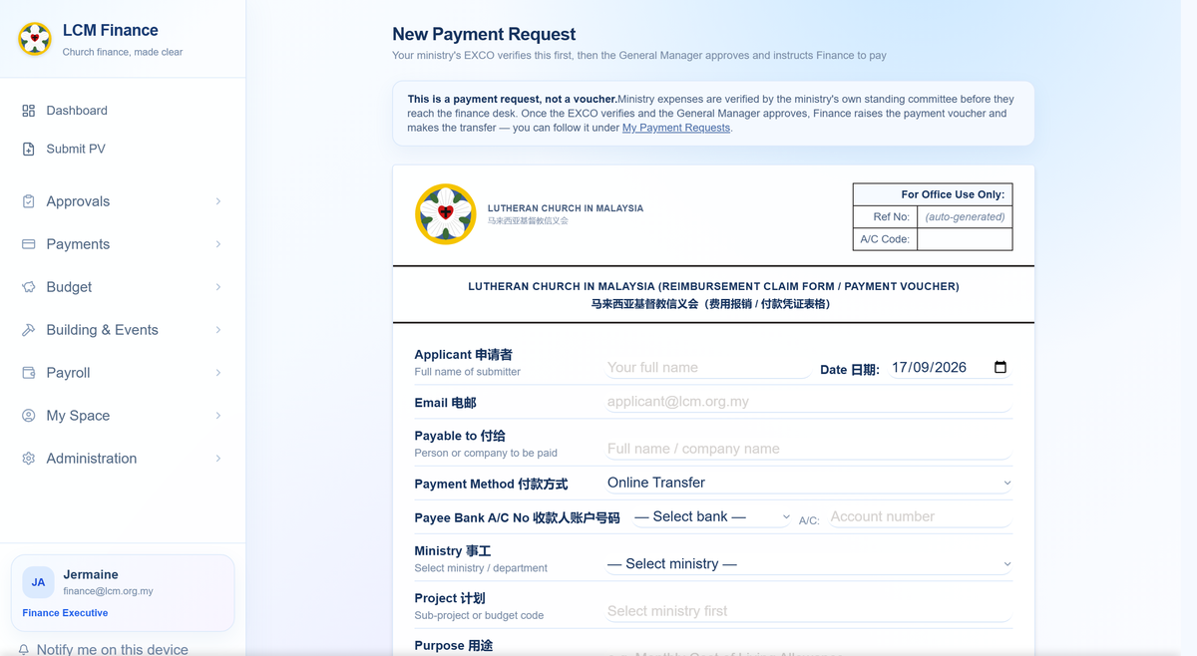
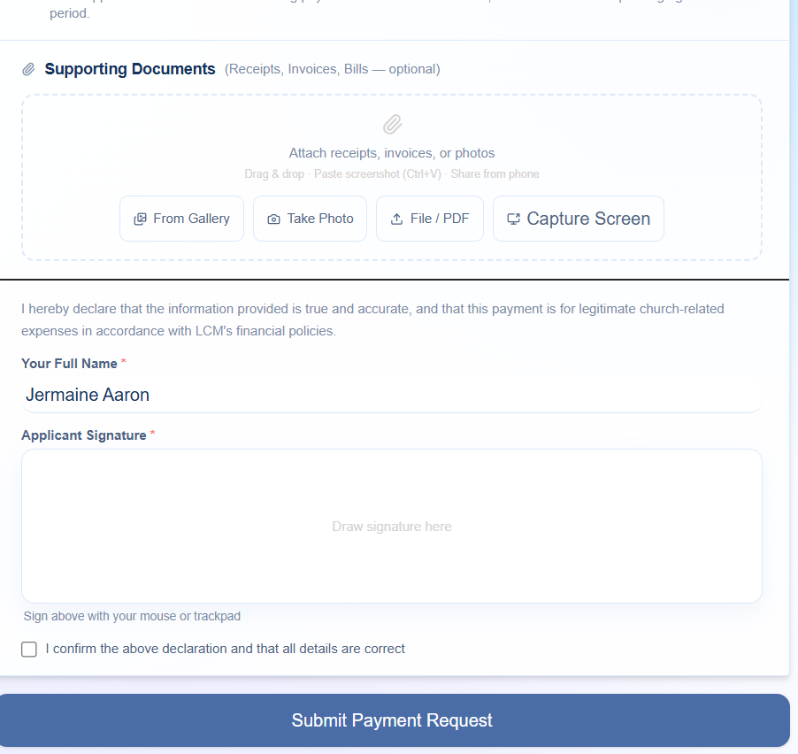
The form on a computer. On a phone it becomes one column with the same fields in the same order — nothing is left out of the small version.

What happens after you send it
You do not have to chase it. The claim goes to the ministry’s EXCO Member, then to Finance, then to the General Manager, then to the officers who sign. You can see where it has reached at any time under My Submissions, and whoever it is waiting on is named there.
You will be told, not left wondering. Each step emails you as it happens. If a claim is sent back, the reason is on it — correct that one thing and send it again rather than starting afresh.

The church directory
Who the pastors are, which congregation sits in which district, and who currently holds each office.
Open The Church in the left-hand list, then Church Directory for the districts and congregations, or Elected Offices for who holds what. Both are there to be read; neither asks anything of you.
Something out of date? Inform the Admin Executive rather than working around it. The directory is what the app uses to decide who approves your leave and where a claim is routed, so a wrong entry there quietly sends things to the wrong person.

If something is not right
Three things go wrong often enough to be worth saying plainly.

The app shows less than this guide describes
Your role is probably not set yet, or is set to the wrong one. Your name and role are at the foot of the left-hand list. Ask the HQ office to correct it, then sign in again.

You pressed save and nothing happened
Tell somebody rather than pressing it again. A save that does not happen, with no error, usually means the record is not yours to change — and it is worth knowing about rather than working around.

Something has been waiting for days
Open it. Whatever it is waiting on is named on the item itself, with the step it has reached. For a payment request there is a Remind button that emails the person it is sitting with — use it rather than wondering.
The whole system, in one document. This guide covers your part of it. The full LCM Finance & HR Handbook describes everything — every role, every stage, the rules behind the approval limits — and the HQ office can send it to you.

Prepared for the Lutheran Church in Malaysia. This guide covers asking for a payment, verifying your ministry's spending, and your ministry's budget — the rest of the system is in the full LCM Finance & HR Handbook, which the HQ office can send you. Anything unclear here is worth saying so: a step that needed explaining twice is a step written badly.

Date of Amendment:
October 2026

